1.Application: Data Backup Optimization System A backup system uses an algorithm with recurrence T(n) = 2T(n/2) + √n. Apply the Master Theorem to determine the time complexity. Compare f(n) with n^log_b a and identify the correct case. Analyze performance for large datasets. Interpret efficiency.

Aim
To determine the time complexity of the recurrence relation
$$T\left(n\right)=2T\left(n/2\right)+\sqrt{n}$$
using the Master Theorem, compare $f\left(n\right)$with $n^{\log_{b}a}$, identify the applicable case, and analyze the algorithm's efficiency for large datasets.

Algorithm
Given
$$T\left(n\right)=2T\left(n/2\right)+\sqrt{n}$$
where
- a = 2
- b = 2
- f(n) = √n

Step 1: Find $n^{\log_{b}a}$
$$\log_{2}2=1$$
Therefore,
$$n^{\log_{b}a}=n$$

Step 2: Compare $f\left(n\right)$
$$f\left(n\right)=\sqrt{n}=n^{1/2}$$
Compare
$$n^{1/2}$$
with
$$n^{1}$$
Since
$$n^{1/2}<n$$
the function grows slower than $n$.

Step 3: Apply Master Theorem
The Master Theorem states
If
$$f\left(n\right)=O\left(n^{\log_{b}a-ϵ}\right)$$
for some
$$ϵ>0$$
then
Case 1 applies.
Here
$$ϵ=\frac{1}{2}$$
Hence,
$$f\left(n\right)=O\left(n^{1-\frac{1}{2}}\right)$$
Therefore,
Case 1 is satisfied.

Final Time Complexity
$$\boxed{T\left(n\right)=Θ\left(n\right)}$$

Analysis
Parameter | Value
a | 2
b | 2
log₂2 | 1
n^(log₂2) | n
f(n) | √n
Master Theorem Case | Case 1
Complexity | Θ(n)

Performance for Large Datasets
The algorithm has linear time complexity.
This means:
- Doubling the amount of data approximately doubles the running time.
- The recursive calls dominate the execution.
- The additional work of √n at each level is comparatively small.
- The algorithm scales efficiently for large backup operations.
Example:
Dataset Size | Estimated Work
1,000 files | 1,000 units
10,000 files | 10,000 units
100,000 files | 100,000 units
1,000,000 files | 1,000,000 units
The running time increases proportionally with the input size.

Source_Code

import math

def master_theorem():
# Given recurrence
# T(n) = 2T(n/2) + √n

a = 2
b = 2

log_value = math.log(a, b)

print("Data Backup Optimization System")
print("--------------------------------")
print("Recurrence Relation:")
print("T(n) = 2T(n/2) + √n\n")

print("Step 1:")
print(f"a = {a}")
print(f"b = {b}")
print(f"log_b(a) = {log_value}")

print("\nStep 2:")
print("f(n) = √n = n^(1/2)")
print("n^(log_b(a)) = n^1")

print("\nComparison:")
print("√n grows slower than n")

print("\nMaster Theorem Case:")
print("Since f(n) = O(n^(1-ε)), Case 1 applies.")

print("\nTime Complexity:")
print("T(n) = Θ(n)")

print("\nInterpretation:")
print("The backup algorithm runs in linear time.")
print("It scales efficiently even for large datasets.")

master_theorem()

Sample Output
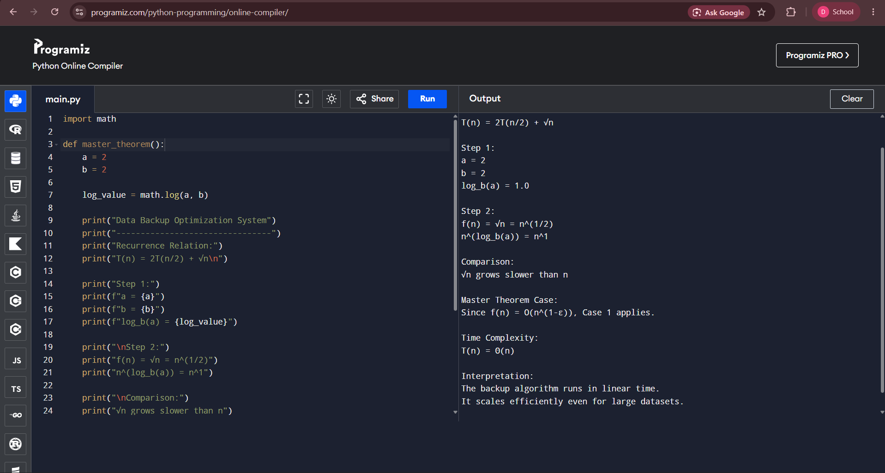

Screenshots to Include
Your report should contain the following screenshots:
- Source Code Screenshot
  - Capture the complete backup_optimization.py code in your IDE (e.g., VS Code or PyCharm).
- Output Screenshot
  - Run the program and capture the terminal showing the output.
- Analysis Screenshot
  - Include the Master Theorem calculations:
    - $a=2$
    - $b=2$
    - $n^{\log_{b}a}=n$
    - $f\left(n\right)=\sqrt{n}$
    - Case 1
    - $T\left(n\right)=Θ\left(n\right)$
- Documentation Screenshot
  - Include the algorithm explanation, complexity analysis, and interpretation from the report.

Conclusion
Using the Master Theorem, the recurrence relation
$$T\left(n\right)=2T\left(n/2\right)+\sqrt{n}$$
falls under Case 1, because $f\left(n\right)=\sqrt{n}$grows asymptotically slower than $n^{\log_{2}2}=n$. Therefore, the time complexity is:
$$\boxed{T\left(n\right)=Θ\left(n\right)}$$
This indicates that the data backup optimization algorithm is efficient and scales linearly, making it suitable for handling large datasets.

2 . Application: Robotics Path Planning System
A robotic navigation system processes paths using the recurrence T(n) = 2T(n/4) + n2. Apply the Master Theorem to determine the time complexity. Clearly identify parameters and justify the selected case. Analyze performance for complex environments. Interpret efficiency using asymptotic notation.

Aim
To determine the time complexity of the recurrence relation
$$T\left(n\right)=2T\left(n/4\right)+n^{2}$$
using the Master Theorem, identify the correct case, analyze the performance in complex robotic environments, and interpret the efficiency using asymptotic notation.

Algorithm
Given
$$T\left(n\right)=2T\left(n/4\right)+n^{2}$$
where
- a = 2
- b = 4
- f(n) = n²

Step 1: Find $n^{\log_{b}a}$
$$\log_{4}2=\frac{1}{2}$$
Therefore,
$$n^{\log_{4}2}=n^{1/2}$$

Step 2: Compare $f\left(n\right)$
$$f\left(n\right)=n^{2}$$
Compare
$$n^{2}$$
with
$$n^{1/2}$$
Since
$$n^{2}$$
grows much faster than
$$n^{1/2},$$
we have
$$f\left(n\right)=Ω\left(n^{1/2+ϵ}\right)$$
where
$$ϵ=\frac{3}{2}>0.$$
The regularity condition is satisfied because
$$a f\left(n/b\right)=2{\left(\frac{n}{4}\right)}^{2}=\frac{n^{2}}{8}≤c n^{2}$$
for some constant
$$c<1.$$

Step 3: Apply Master Theorem
Since
$$f\left(n\right)=Ω\left(n^{\log_{b}a+ϵ}\right)$$
and the regularity condition holds,
Master Theorem – Case 3 applies.

Final Time Complexity
$$\boxed{T\left(n\right)=Θ\left(n^{2}\right)}$$

Analysis
Parameter | Value
a | 2
b | 4
log₄2 | 1/2
$$n^{\log_{b}a}$$ | $$n^{1/2}$$
$$f\left(n\right)$$ | $$n^{2}$$
Master Theorem Case | Case 3
Time Complexity | Θ(n²)

Performance for Complex Environments
The robotic navigation algorithm recursively divides the planning problem into smaller subproblems. However, the quadratic processing cost ($n^{2}$) at each stage dominates the recursion.
This means:
- The recursion contributes relatively little to the total running time.
- The path evaluation and obstacle-processing operations dominate execution.
- As the environment becomes larger and more complex, the running time increases quadratically.
Example:
Environment Size | Estimated Work
100 nodes | 10,000 operations
500 nodes | 250,000 operations
1,000 nodes | 1,000,000 operations
5,000 nodes | 25,000,000 operations

Source Code
import math

def master_theorem():
# Given recurrence
# T(n) = 2T(n/4) + n^2

a = 2
b = 4

log_value = math.log(a, b)

print("Robotics Path Planning System")
print("--------------------------------")
print("Recurrence Relation:")
print("T(n) = 2T(n/4) + n²\n")

print("Step 1:")
print(f"a = {a}")
print(f"b = {b}")
print(f"log_b(a) = {log_value}")

print("\nStep 2:")
print("f(n) = n²")
print(f"n^(log_b(a)) = n^{log_value}")

print("\nComparison:")
print("n² grows faster than n^(1/2).")

print("\nMaster Theorem Case:")
print("Since f(n) = Ω(n^(1/2 + ε)), Case 3 applies.")

print("\nTime Complexity:")
print("T(n) = Θ(n²)")

print("\nInterpretation:")
print("The algorithm is dominated by the path-processing cost.")
print("It performs efficiently for recursive decomposition but")
print("overall execution grows quadratically with input size.")

master_theorem()

Sample Output
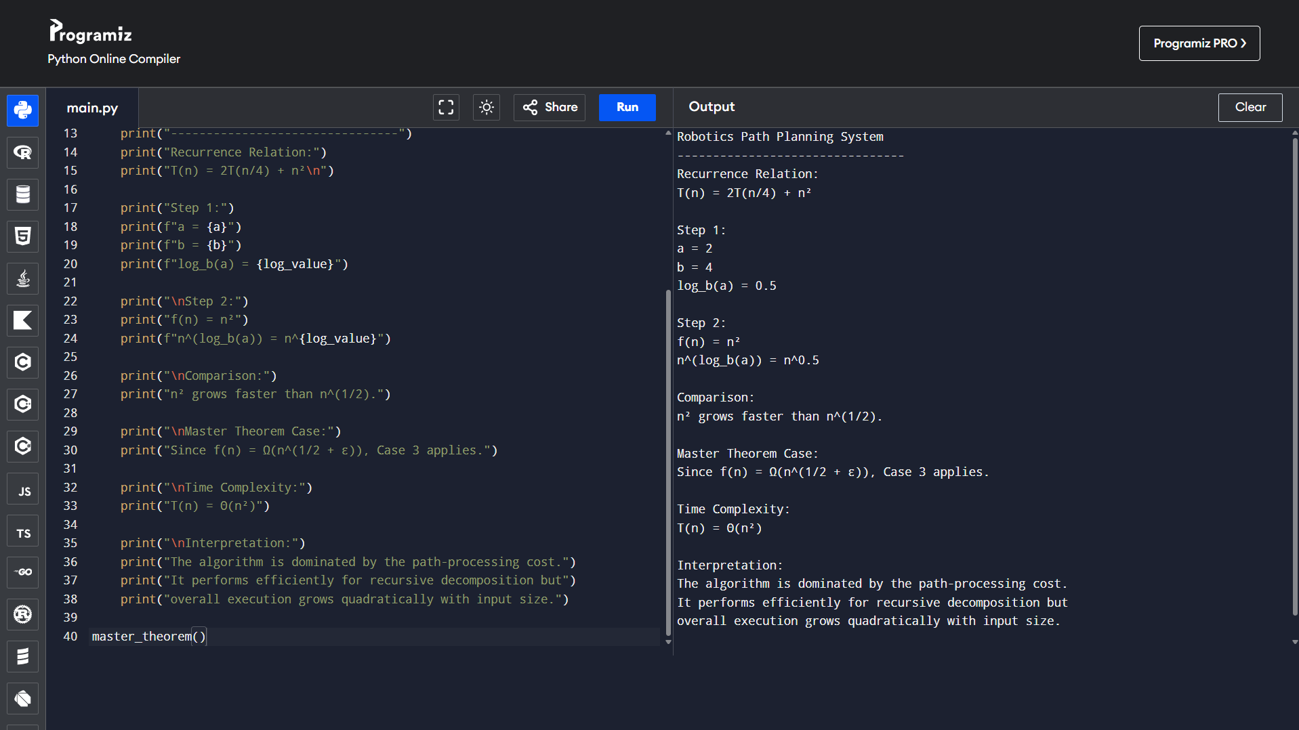

Screenshots to Include
Your report should include the following screenshots:
- Source Code Screenshot
  - Capture the complete robotics_path_planning.py code in your IDE (e.g., VS Code or PyCharm).
- Output Screenshot
  - Run the program and capture the terminal showing the output.
- Analysis Screenshot
  - Include the Master Theorem calculations:
    - $a=2$
    - $b=4$
    - $n^{\log_{4}2}=n^{1/2}$
    - $f\left(n\right)=n^{2}$
    - Case 3
    - $T\left(n\right)=Θ\left(n^{2}\right)$
- Documentation Screenshot
  - Include the algorithm explanation, complexity analysis, and interpretation from the report.

Conclusion
Using the Master Theorem, the recurrence relation
$$T\left(n\right)=2T\left(n/4\right)+n^{2}$$
falls under Case 3, because $f\left(n\right)=n^{2}$grows asymptotically faster than $n^{\log_{4}2}=n^{1/2}$, and the regularity condition is satisfied. Therefore, the time complexity is
$$\boxed{T\left(n\right)=Θ\left(n^{2}\right)}$$
This indicates that the robotics path planning algorithm is dominated by the quadratic processing cost, making it suitable for moderate-sized environments, though execution time increases significantly as the complexity of the environment grows.

